

DEPARTMENT OF COMPUTER SCIENCE AND ENGINEERING
(CYBER SECURITY)

CR23532
CYBER AND DIGITAL FORENSICS

CASE STUDY ASSIGNMENT-2

Student information | Details
Name | Keerthika K
Reg. No. | 241901046
Dept. | CSE(cyber security)

October 2026

Part | Unique scenario title
2(1) | After-Hours Copy of an Internal-Assessment Question Bank
2(2) | Shared Placement-Cell Desktop and a Disguised Résumé-Tool Executable
2(3) | Seizure of a Faculty Research Laptop and USB Drive
2(4) | Deleted Hostel Mess-Payment Register Recovered from Shadow Copies
2(5) | Misused Library E-Journal Account Across Five Sources
This submission answers all 38 questions of the handout across five case studies. Each case has its own hypothetical scenario, stated assumptions and the deliverables the handout asks for.

ASSIGNMENT 2(1) · After-Hours Copy of an Internal-Assessment Question Bank
Case scenario (hypothetical): At about 1:15 a.m. on Sunday, 11 October 2026, the CSE department's file server CSE-FS02 records an unusual session on the IA_Papers share, which holds internal-assessment question banks and answer keys. The college has authorized the examination of four things only: a staff workstation LAB3-PC22, a 16 GB USB drive labelled PEN-K3 recovered from it, the server access logs, and a few relevant files.
Assumptions: (1) The Principal's written authorization covers exactly these items. (2) File auditing was enabled on the share. (3) The server and workstation clocks have not yet been verified. (4) LAB3-PC22 was found switched on. (5) Who was sitting at the keyboard is unknown.
What the investigation must establish. Two explanations need testing. H1: someone used LAB3-PC22 to open the folder and copy it to PEN-K3. H0: a legitimate task such as moderation, backup or a scheduled sync explains the activity. An odd login time is a reason to investigate. It does not by itself show that a person stole anything.

Phase | What I would do in this case | Hand-off record
Identification | Take the administrator's written complaint and fix a time window (10–11 October). List the sources: server, audit logs, LAB3-PC22, PEN-K3, the exam files, door-access and CCTV records. Ask for the logs to be preserved before they roll over. | Complaint, scope note, authorization copy
Collection | Photograph and label each item. Decide whether a documented RAM capture of the running workstation is justified before shutdown. Image the disk and the USB through a write blocker. Export server logs using read-only procedures. Calculate SHA-256 hashes. | Exhibit list, acquisition logs, hash sheet, chain of custody
Examination | Work only on forensic copies. Extract server logons, file-access events, recent files, link files and USB connection traces. The aim here is to find and extract artifacts, not to decide who is responsible. | Extraction log pointing each item to its source image
Analysis | Put the events in time order. Compare account, host and IP, file metadata and USB serial number, correcting for clock differences. Look actively for evidence that supports H0. | Working timeline, hypothesis table
Presentation | Prepare a report that explains what was found, how the evidence was handled and how strong each conclusion is, in language the committee can follow. | Final report and exhibits

Q1. Identification, collection, examination, analysis and presentation
Findings about access, copying, removal and the responsible person are stated separately, because proving one does not automatically prove the next.

Q2. Forensic investigation flowchart
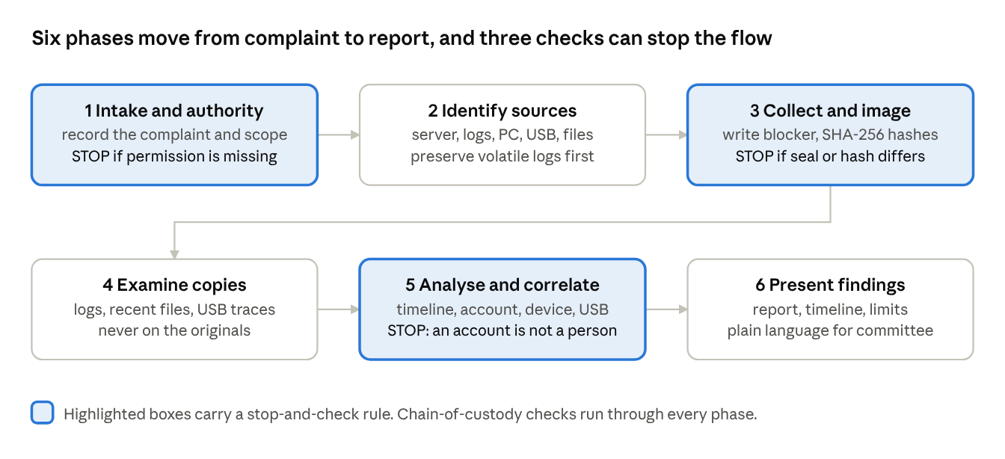
Figure 1 · investigation flowchart, 6 phases, 3 stop-and-check rules
Three stopping points apply. If permission to collect a source is missing, collection stops. If a seal or hash does not match, the discrepancy is investigated before the copy is relied on. If a file is tied only to an account and not to a person, the report must say so.

Q3. Potential digital evidence and its investigative value
ID / source | Potential finding | Investigative value | Main caution
E01 Administrator's complaint | Discovery time, suspected loss, who normally has access | Medium (lead and scope) | A statement is not technical proof
E02 Server access logs | Logon, account, host/IP, file-open events on IA_Papers | High (primary, server side) | A read event does not prove a download
E03 LAB3-PC22 image | Recent files, link files, event logs, user profile, USB history | High | A shared lab PC complicates identity
E04 PEN-K3 image | Matching archive or recovered fragments, last-written times | High (possible destination) | Anyone could have placed files on it
E05 Question-bank files | Name, size, MAC timestamps, SHA-256 | High (object comparison) | Times change when files are copied
E06 Account and DHCP records | Account privileges, IP lease mapping | Medium (corroboration) | NAT and lease reuse can mislead
E07 Door-access and CCTV | Who was in the building in the window | Medium (context) | Presence is not keyboard activity
E08 Attendance sheet | Who was on campus that night | Low (background) | Weak on its own
A verified copy of the exact archive on PEN-K3 would carry much more weight if the server log also shows access at the same time. A matching SHA-256 shows the contents are identical. It does not show who made the copy.
What I would preserve first. Authentication, network and USB connection records go first because they can be overwritten quickly. Disk images follow. I would keep the full acquisition even if only a few extracts appear in the report.

Q4. Precautions during collection and preservation
- Authorization and privacy: confirm exactly what the college allows. Do not review unrelated student or staff data.

Scene documentation: before unplugging anything, photograph the screen, USB ports, labels and cables, and note whether the machine is running, asleep or off.
- Preventing change: use a tested write blocker and examine a forensic image, never the original disk. Record the tool version and settings.
- Integrity: calculate SHA-256 for every image and export, and keep the acquisition logs. If there are unreadable sectors or a hash mismatch, document it instead of presenting a spotless record.
- Order of volatility: capture RAM and network state before disk if the machine is live, and note that a live response itself changes the system.
- Storage: give each exhibit a unique ID, seal it with a tamper-evident seal, and record every handover in the chain of custody.
- Honest records: include failed reads, clock differences and any action that may have altered the device. Leaving them out would weaken the case.

Q5. Establishing the timeline
I would put every useful event in one worksheet with the original timestamp, its time zone, the UTC equivalent, the evidence ID and a one-line meaning. Before merging sources I would compare the server and workstation clocks with a trusted reference and record any offset, so that two events do not appear in the wrong order. Server logs give the session, workstation artifacts give device activity, file metadata gives the object history, and door or CCTV records give physical context.
Time (IST, hypothetical) | Possible event | Source | What it does and does not establish
11 Oct 01:08 | Account lab_asst2 signs in to CSE-FS02 | E02 + E06 | A server session exists; not who was typing
11 Oct 01:15 | IA_Papers archive opened/read | E02 | File access; destination unknown
11 Oct 01:17 | PEN-K3 first attached to LAB3-PC22 | E03 | USB attached; copying still unproven
11 Oct 01:21 | Matching archive appears on PEN-K3 | E04 + E05 | Strong support for H1 if hashes match
11 Oct 08:40 | Administrator notices the activity | E01 | Discovery time, not incident time
The 01:21 entry is only a possible event, not something recovered from a device. In a real case I would first confirm the archive on the USB by hash, then look for a matching transfer on the workstation. The timeline becomes convincing when different sources support the same sequence.

Q6. Final forensic report and presenting to a non-technical authority
Section | Content
1. Authorization and scope | Who asked for the work, the authority, the time range, exclusions
2. Evidence register | IDs, seals, owners, sources, hashes, transfer records
3. Methods | Isolation decisions, write blocking, imaging steps, tools and versions
4. Verified observations | Timestamped events with exact source references; facts kept apart from inferences
5. Findings and alternatives | Evidence for H1 and for H0; limits on identification
6. Conclusions | What is established, what is likely, what is not established; confidence
7. Appendices | Hash manifest, log excerpts, timeline, chain of custody, approvals
Example finding F-01. The hypothetical records would show a server login and access to the question bank outside approved hours. If an independently verified SHA-256 match were found on PEN-K3 and the USB connection times aligned, unauthorized copying would be a credible explanation. Naming an individual would still depend on separate evidence of who held the account and who used the machine.
For non-technical staff I would keep the briefing short: describe the concern, show the key events on a simple timeline, and explain what the evidence does and does not show. Saying that the account opened the archive at 1:15 a.m. is safer than calling someone a thief. A hash can be described as a digital fingerprint of a file, and chain of custody as the record of everyone who handled it.

Q7. Legal and ethical considerations in a college environment
The evidence includes examination material and personal data, so the team needs written authority, a limited purpose and careful handling. Permission to monitor a server does not extend to reading unrelated private messages. Relevant Indian provisions include the IT Act, 2000 (Sections 43 and 66 on unauthorized access), the admissibility rules for electronic records (Section 63 of the Bharatiya Sakshya Adhiniyam, 2023, which replaced Section 65B of the Evidence Act) and the data-protection rules; the college's legal adviser should confirm what applies.
- Fair treatment: the affected person should get a chance to explain, and evidence pointing away from the first suspicion must also be kept.
- Confidentiality: keep question papers and personal identifiers visible only to authorized people, and redact unneeded details in committee copies.
- Proportionality: search no wider than the case needs, never alter originals, and never circulate raw evidence through personal email or chat.
- Retention: record who accessed the evidence, how long it is kept, and how verified copies go to an authority.

My assessment of the case
I would separate two questions: was the archive accessed or copied without permission, and can the responsible person be identified? Logs might establish access, and a matching file with USB traces could support copying, but the account owner is not automatically the operator. Shared credentials, remote access or a hijacked session could produce the same evidence.
Claim | Minimum support expected | Residual uncertainty
File accessed | Authenticated server audit record for the named archive | Account misuse or a service action
File copied to USB | Complete matching contents plus contemporaneous workstation and USB artifacts | Who placed it there, and when
A named person operated the device | Independent logon evidence, presence (physical or remote) and corroboration | Shared access, spoofing or compromise
At this stage the matter is still an allegation. The proposed process lets the college decide carefully without exposing the papers or blaming a person before the evidence has been checked.

ASSIGNMENT 2(2) · Shared Placement-Cell Desktop and a Disguised Résumé-Tool Executable
Case scenario (hypothetical): The Training and Placement Cell desktop TPC-PC-05 is used by four people: tpc_admin, coord1, coord2 and a student intern, intern.meera. Investigators found an executable named resume_tool.exe inside a hidden folder under C:\ProgramData\Fonts\, an encrypted archive company_contacts.7z, several hidden files and browser downloads. The cell suspects the coord2 account created and used these files. A verified disk image is available and ILookIX is the planned analysis tool.
Assumptions: (1) Written authorization is in place. (2) The disk image has been hash-verified. (3) Windows logon auditing was partly enabled. (4) The password for the archive is not available. (5) No suspect is confirmed; the case is a planned examination.

Q8. Hardware and software inventory to document before analysis
Item | What the examiner records | Why it matters
Computer | Make, model, asset tag, serial number, photographs, peripherals | Provenance and scene context
Storage | HDD/SSD model, capacity, serial number, partitions, sector size, encryption status | Identifies the exact image source and its limits
Memory and boot | RAM size, power state at seizure, boot order, external media | Possible volatile artifacts
BIOS/UEFI | Firmware clock, date, time-zone offset | Timestamp reliability
Operating system | Windows edition and build, install date, time zone, locale | Decides parsers and artifact locations
File system | NTFS volumes, mount points, ACLs, $MFT and USN journal availability | Recoverable activity metadata
User accounts | Names, SIDs, last logon, privileges, profile folders | Basis for any attribution
Applications | Browsers, archivers, remote-access tools, scheduled tasks | Benign or suspicious execution clues
Security software | Antivirus or EDR, audit policy, log size | What activity would have been recorded
Network | Host name, IP and MAC, domain membership, proxy or VPN | Cross-system correlation
Most of this comes from scene notes and a read-only image. I would not boot the original machine just to fill a missing field.

Q9. How storage, operating system, file system and metadata help locate evidence
The storage device holds active files, deleted-file remnants and unallocated space. On NTFS, the Master File Table ($MFT) records file names, paths, sizes and timestamps, and the USN journal records changes. Windows adds user profiles, registry hives, event logs, prefetch data, shortcut files and browser databases, which show how a file was obtained and used.
Metadata such as created, modified, accessed and MFT-changed times, file ownership, hashes and the executable's header details are clues. They have to be read together, because one timestamp cannot prove that someone ran a program. For resume_tool.exe I would compare its folder, file-system record, browser download history, shortcuts, execution traces and scheduled tasks, and check whether it was renamed or moved. If the drive is an SSD, TRIM may already have removed some deleted data.

Q10. Hidden and encrypted files, and how to handle them
A hidden attribute only keeps a file out of ordinary folder views, so it is not proof of bad intent. I would examine hidden and system folders, alternate data streams and deleted entries from the image, leaving the original attributes untouched. A misleading name or extension is a reason to inspect the file, not evidence of concealment.
Encryption means the investigator may see that a file exists but not read it. Whether the protection is on a document, an archive or a whole disk, any recovery key must be used only with proper permission and on a copy. Filenames, sizes, application traces and metadata can still help answer the case questions. I would not describe the content of company_contacts.7z until it has been lawfully opened.
- Record each file's full path, volume identifier and the image it came from.
- Give extracted files their own SHA-256 hashes, and record any step that changes them (decryption, decompression).
- If a key is legally provided, use it on a duplicate image and keep the encrypted and decrypted versions under separate IDs.
- Store passwords and keys securely, log who accessed them, and keep unrelated contact data out of the report.
Observation | Interpretation if confirmed | Competing explanation
resume_tool.exe is hidden and sits in ProgramData | Possible staging or evasion | An installer placed it there
Hash matches a known malicious or approved binary | Useful classification clue | A hash does not identify the operator
Archive created during coord2's session | Possible account interaction | Background sync or automation
Download URL in the browser matches the file | Source of the file supported | Another user used the same browser profile

Q11. Evidence-linkage matrix: file to user account
The entries below are illustrative, not findings from TPC-PC-05.
Artifact | Illustrative linkage | What it may support | Strength and caveat
File name and path | C:\Users\coord2\Downloads\resume_tool.exe before a move to ProgramData | File first appeared in coord2's profile | Medium: a path is not a person
$MFT / USN journal | Created 15:42, later renamed and moved 16:05 | Object history and movement | Medium: copied files can carry old times
NTFS owner / ACL | Owner SID matches coord2 | Account that created the file | Medium to high for the account
Windows logon events | coord2 session 15:30–16:40 | Session overlaps creation | High for the account, not the operator
Browser downloads | Download record in coord2's Chrome profile, 15:40 | How the file arrived | Medium: profile may be shared
Prefetch / execution traces | RESUME_TOOL.EXE prefetch with last-run 15:44 | The binary ran | Depends on artifact and OS settings
Recent files / link files | Shortcut to the encrypted archive in coord2's Recent folder | Interaction with the archive | Medium: shortcuts can be indirect
Scheduled task | Task "FontSync" points to the executable | Persistence or an approved job | Review who created the task
Hidden folder metadata | Folder attributes set 16:05 | When it was concealed | Supporting only
Duty roster | coord2 on shift that afternoon | Availability | Supporting only
I would rely on stable identifiers: file hashes over filenames, account SIDs over display names, and all times converted to one zone.

Q12. Workflow for importing or acquiring evidence and analysing it in ILookIX
ILookIX menus and supported image formats differ between releases, so I describe the checks an examiner makes rather than inventing screenshots. If ILookIX were unavailable, a validated alternative could be used and named in the report.
- Receive the authorized evidence, check exhibit IDs and verify the image hash. Importing an image is not the same as acquiring the original disk.
- Create a case and record the examiner, the tool version, the workstation clock and the settings used.
- Import the verified image, note the partitions and file systems the tool recognizes, and record any errors. Keep the original and any converted copy.
- Index and browse: review the file listing, hidden and deleted files, file signatures against extensions, and signs of encryption. Record the hash of resume_tool.exe and compare it with a trusted source.
- Analyse user artifacts: profiles and SIDs, browser downloads, shortcuts, execution traces, scheduled tasks and registry data. Save each search term, hash and date range so the search can be repeated.
- Export relevant artifacts with path, timestamps, source image and hash, and treat each export as its own exhibit.
- Correlate the results with independent logs and account records and prepare an evidence index another examiner can check.
Expected outputs: a verified import record, partition and account inventory, filtered file listing, executable hash and metadata, account-artifact links, an export manifest and an analysis log. These are the outputs I would expect, not results of a tool run.
Validation checkpoint. Before concluding, I would reopen a few exports in a second viewer and re-check their hashes. I would also list what the software could not parse, such as encrypted content, and not treat a missing result as proof that nothing happened.

Q13. Direct link versus supporting information
A direct artifact records the activity itself and ties it to an account. For example, a trustworthy process-execution audit keyed to an account SID may link a program run to that account. Even then it does not show which human was at the keyboard. Supporting artifacts, such as a file found in a profile, a duty roster or a matching IP address, have several possible explanations.
Claim | Direct, account-linked artifact | Supporting context
A given account ran the executable | Process-execution audit with account SID and executable identity | Download history, same-profile file path
The program opened the archive | File-open audit tying the process to the object | Timestamps, a recent-files shortcut
A named person operated the machine | Independent authenticated identity plus corroboration | Duty roster or badge presence alone

Q14. Limitations and alternative explanations
- Shared access: a colleague could have used an unlocked session or a remote-control tool, even though the account belongs to someone else.
- Unreliable time order: copied files, restored backups, delayed writes and wrong clock settings can change how events appear.
- Background software: updaters, antivirus scans, scheduled tasks and backups can create files or launch programs without a click.
- Missing evidence: cleared browser history, rotated logs, disabled auditing and SSD TRIM can remove context.
- Mistaken suspicion: a hidden folder or an odd name is worth checking but may belong to legitimate software.
Balanced conclusion for this scenario. If browser, NTFS and execution evidence all point to the coord2 account, an account-level connection could reasonably be reported. I would not name the account owner as the operator until shared access, automation and remote sessions have been ruled out. The report should identify the executable by hash and say clearly whether its behaviour was actually tested. At present there is no confirmed suspect.

ASSIGNMENT 2(3) · Seizure of a Faculty Research Laptop and USB Drive
Case scenario (hypothetical): A faculty member reports that unpublished research data and a draft patent disclosure may have been copied out of the department. On 12 October 2026 investigators seize a laptop, FAC-LT-09, and a 128 GB USB drive from a locked drawer in a faculty cabin. The laptop is switched off. The priority is to collect both devices safely and make verified images before anyone opens a file.
Assumptions: (1) A written seizure authorization names both devices. (2) The laptop has an internal SSD with a Windows NTFS volume. (3) A hardware write blocker, an evidence-storage drive and IXImager are available in the laboratory. (4) The disk may be encrypted, and no key is available yet. (5) This is a planned procedure; no acquisition has been performed.
Exhibit IDs I would use: FLT-01 laptop, FLT-02 USB drive, FLT-03 laptop image, FLT-04 USB image. A working copy gets a linked ID such as FLT-03-W1, so every later result can be traced back to its source.

Q15. Safe collection and transport before imaging
- Confirm authority: check the written permission, the case number and the exact location it covers, and note who carries out the seizure.
- Photograph the scene: the drawer, laptop, USB drive, charger, ports, labels and any damage. Record who can open the drawer.
- Check the power state: a dark screen does not prove the laptop is off. Do not switch it on or connect it to a network. If it turns out to be on, follow an approved live-response decision instead of guessing.
- Record connections: note every cable and device before disconnecting, and package the USB drive as its own exhibit, noting the port it came from.
- Identify and label: record make, model and serial number for both items, attach tamper-evident labels and give each its own exhibit ID.
- Pack and protect: use anti-static bags or padded containers, keep the charger with the laptop, and avoid heat, moisture, magnets and shocks.
- Transport: move the sealed exhibits directly to the laboratory with a named carrier and sign the chain-of-custody form at each handover.
- Store: place them in a secure intake area with restricted access until imaging.
Laptop-specific caution: sleep or hibernation, hardware encryption and modern SSD behaviour can change the correct acquisition decision. I would record the method chosen and why the risk was acceptable.

Q16. Purpose of physical acquisition, and why the image is examined
Physical acquisition copies every addressable sector of a storage device, not only the files visible in a file browser. It captures active files, file-system structures and remnants in unallocated space. I would normally analyse a verified image because opening files on the original, or even mounting it, can change timestamps and write temporary data. Keeping the original untouched also lets another examiner repeat the work, and a damaged working copy can be recreated from the master image.
A physical image still does not promise that every old byte is available. SSD TRIM, encryption, unreadable sectors and firmware-managed areas can limit recovery. The report should state whether the acquisition covered the whole disk, one partition or only selected files.

Q17. Forensic imaging workflow using IXImager
IXImager is a forensic imaging tool associated with the ILook family. Its available options depend on the version, so in a real laboratory I would first confirm the version and whether it supports the evidence devices and the planned image format. The workflow below is a plan, not a record of a tool run.
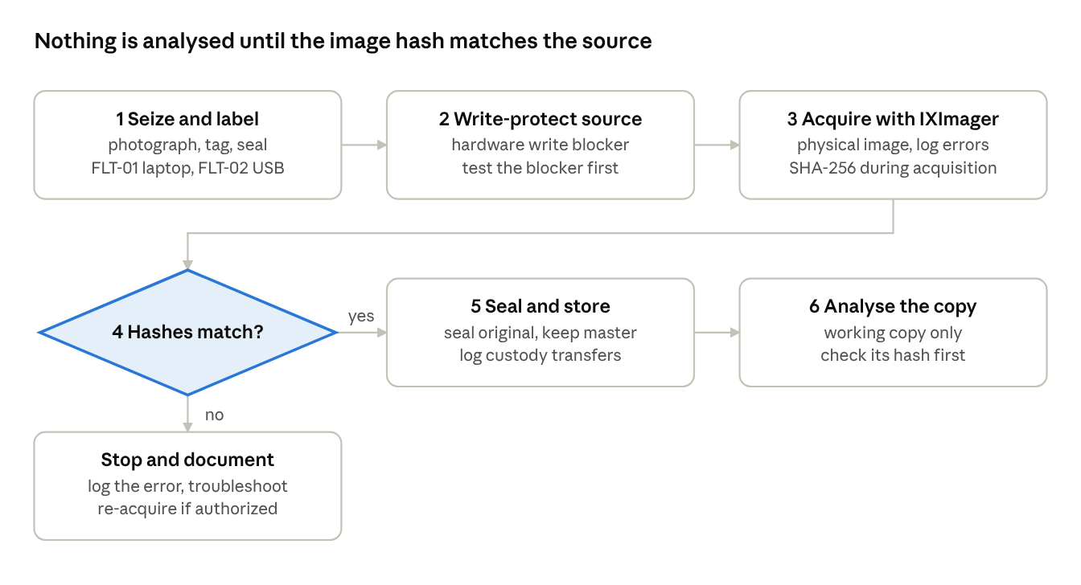
Figure 2 · IXImager acquisition flowchart with the hash decision
Gate | Procedure | What is recorded
Source identification | Note make, model, serial, interface and capacity of the SSD and the USB drive; compare with the scene inventory | Source description, photographs
Write protection | Connect through a hardware write blocker (or a write-protected forensic boot) and test that it blocks writes | Blocker model and test result
Destination | Prepare a clean, sufficiently large evidence drive with a separate case folder | Destination ID and free space
Imaging | Select the physical source, choose the supported image or container option, start acquisition | Tool and version, operator, start and end time, errors, split files
Verification | Compare the image with the source using the tool's verification and a read-back hash | Verification result, size and sector coverage
Hashing | Calculate SHA-256 (and MD5 if the lab policy requires) for the image and each segment | Hash manifest
Documentation and preservation | Seal the original, store the master image, create a working copy | Custody entries, storage location
I would image the laptop and the USB drive separately. Each has its own serial number, size, log, hash and custody history, so an image of the laptop cannot stand in for the USB drive. Reaching 100% on a progress bar is not enough: I would check the final status and any bad-sector warnings. Choosing the destination by mistake could destroy evidence, so the source and destination are confirmed before starting.

Q18. How hash values demonstrate integrity before and after acquisition
A cryptographic hash such as SHA-256 gives the same value for the same bytes, and a different value if even one bit changes. I would record hashes at set points: acquisition, verification, copying and each later access. The comparison must be between the same kind of data. The hash of a compressed container will not normally equal the hash of the raw disk data inside it, though both can be correct if their meaning is documented.
Checkpoint | What to record | Decision rule
At acquisition | Source hash read through the write blocker, sector range, read errors | Sets the baseline and notes its limits
After imaging | Hash of the reconstructed raw data, or the tool's verification result | Compare like with like
Master archive | SHA-256 of every image container and segment | Manifest of files that must not change
Before and after analysis | SHA-256 of the working copy | Investigate any unexplained change
If some sectors cannot be read, I would not claim a perfect source-to-image match. I would list the unreadable block addresses and retries, and state that verification covers only the content actually captured.

Q19. Role of the ASB container
As I understand it from the syllabus, the ASB format is the evidence-container format associated with IXImager and ILook. It keeps the acquired data together with information that supports authentication and integrity checks, so the evidence and its description travel as one unit. Because support differs between tool versions, I would check that the version in use can create and open it, and I would not rely on the file extension as a guarantee of integrity or long-term compatibility.
The following should accompany the ASB image:
- case number, exhibit ID and source device description (make, model, serial number)
- examiner name, acquisition date and time, and the time zone used
- tool name and version, the segment list and the image format
- source and image hash values and the verification result
- read errors, bad sectors and any retries
- chain-of-custody entries and storage details
If a second format is created for compatibility, both versions and the conversion step are documented.

Q20. Data carving
Data carving recovers files directly from raw data by looking for known file structures, such as a header and footer, without relying on file-system records. It is needed when the file system is damaged or formatted, when directory or MFT entries are missing, when a partition has been deleted, or when deleted data remains only in unallocated space.
Carving usually loses the file name, folder and timestamps, so it cannot show ownership by itself. Fragmented files may come back incomplete. I would run carving only on a verified working image, record the offsets, signatures and settings used, and check whether each recovered file opens and is complete. TRIM, overwriting and encryption may leave only partial content or nothing.

Q21. Date and time problems, and how to document them
Problem | What the examiner does
Clock offset or drift | Record the BIOS and OS time and compare with a trusted reference; state the offset and its uncertainty
IST versus UTC | Keep the raw timestamp and its source zone; convert consistently (IST is UTC+05:30)
File-system behaviour | Distinguish created, modified, accessed and MFT-changed times, and note that copying can alter them
Delayed writes and logging gaps | Note caching, rounding, scheduled tasks and missing records
Deliberate time changes | Look for time-service events and independent records; never "fix" the source data
The report states whether each time is local or UTC, names the reference used, and gives the margin of uncertainty instead of claiming exact times the evidence cannot support.

Q22. Chain-of-custody record for the seized laptop (FLT-01)
This is a sample form with fictional people and times. Real entries need real signatures.
Date and time (IST) | From → to | Location and purpose | Seal, condition, signatures
12 Oct 2026, 10:20 | Campus security → Collector A | Faculty cabin; seizure and packing | Seal SL-201 applied; powered off; both sign
12 Oct 2026, 10:50 | Collector A → Transport B | Move to the forensic laboratory | SL-201 intact; both sign
12 Oct 2026, 11:15 | Transport B → Evidence officer C | Laboratory intake and locker entry | SL-201 intact; locker log entry
13 Oct 2026, 09:10 | Evidence officer C → Examiner D | Authorized imaging session | Seal opened and resealing logged
13 Oct 2026, 15:40 | Examiner D → Evidence officer C | Return to locker after imaging | New seal SL-202; both sign
Each real entry should show the exhibit ID, make and serial number, who hands over and who receives, the reason, date and time with time zone, location, seal condition and signatures. If a seal is opened and replaced, both actions appear in the record.
Evidence-integrity statement for the report. The laptop and USB drive will be documented and acquired separately through read-only procedures. The image and acquisition logs will record the source range, errors and verification results. The originals will be secured and examination will take place on working copies. If the disk is encrypted and no authorized key is available, the report will say that part of the evidence could not be examined, because a stated limitation is more defensible than an undocumented step that risks changing the device.

ASSIGNMENT 2(4) · Deleted Hostel Mess-Payment Register Recovered from Shadow Copies
Case scenario (hypothetical): The hostel office computer HOS-PC-02 held a spreadsheet, mess_vendor_payments.xlsx, that is now missing. An office employee is suspected of altering vendor payment entries and then deleting the file and clearing browser history. Investigators have a hash-verified Windows image of HOS-PC-02. It contains NTFS structures and Volume Shadow Copies (VSS). The task is to find out whether an earlier version can be recovered and whether the traces really show a deletion.
Assumptions: (1) Authorization covers this image. (2) VSS was enabled and at least two snapshots exist. (3) The image hash has been verified. (4) Analysis is planned in ILookIX or an equivalent validated tool. (5) The identity of the person who deleted the file is unknown.

Q23. Selecting and categorizing evidence before detailed analysis
I would begin with focused questions. Which version of the register existed before the incident? What changed, when, and was the file deleted or only moved? I would keep the full image but search only the relevant folders, file names, dates and activity records, so unrelated finance and student information is not reviewed.
- Check the image ID and hash, the volumes present, the system clock and whether snapshots exist.
- Identify likely file names and locations, Office recent-file entries, $MFT and USN journal records, Recycle Bin entries and related browser activity.
- Group the material into original content, system activity, recovered copies and supporting records. "Suspicious" only means "needs a closer look".
- Use hash filtering to recognize known system files and duplicates, and keep a record of what was filtered out and why.
- Record the exact dates, keywords and filters used, because several snapshots may hold versions of the same document.

Q24. Classification scheme
Class | Examples in this case | Role in the investigation
User-created files | mess_vendor_payments.xlsx, vendor letters, drafts in the user's Documents | Core business content; compare versions
System and application files | NTFS metadata, Office recovery files, Windows event logs | Show time and software behaviour; parsing must be validated
Potentially suspicious files | A renamed copy of the register, a cleanup script, a wiping tool | Examine behaviour and alternative reasons before labelling
Deleted or recovered artifacts | Recycle Bin entries, versions in a shadow copy, fragments in unallocated space | Earlier states of evidence; record where each came from
Supporting and contextual evidence | Cloud-sync logs, browser history, logon sessions, email to the vendor | Corroborate timing and transfer

Q25. How Event Analysis helps reconstruct activity
Event Analysis brings time-stamped events from different artifacts into one ordered view. Here NTFS may show file changes, Office records an edit, Windows logs which account was signed in, and cloud-sync traces another copy. I would keep raw times beside their UTC conversions.
It helps to see the order of create, modify, copy and delete actions, to spot bursts of activity at odd hours, to find gaps that suggest clearing of records, and to check whether a logon matches the file activity. Each artifact has limits. A last-modified time does not describe every edit, a browser visit does not prove a successful upload, and a deleted entry can come from a normal Office save. The interpretation should say so.

Q26. Cloud Analysis and Lead Analysis
 | Purpose | Questions it can help answer | Caution
Cloud Analysis | Examine evidence tied to online services: sync folders, web-mail, account records, revision history | Was the register synchronized or shared? Which account was used? Does a copy exist outside the PC? | Timestamps and retained versions differ by service; provider records need proper authority
Lead Analysis | Follow names, addresses, accounts and other links found in the data to decide what to search next | Who communicated with whom? Which e-mail address, vendor name or device appears repeatedly? What should be checked next? | A lead is a hypothesis until corroborated
Together | Test whether a local deletion coexists with a retained cloud copy | Does a shadow-copy version match a cloud revision? | A matching name or size does not prove identical content
Example lead workflow. If an older register contains a vendor code such as VND-27, I would search for it in the approved image, check related browser or transfer traces, and then request a narrowly scoped provider export if needed. I would record negative results as well.

Q27. Volume Shadow Copy analysis: recovering and comparing earlier versions
VSS can keep an earlier state of a Windows volume. If the register was changed or removed after a snapshot was taken, the snapshot may still contain the earlier version. A snapshot is a point-in-time view, not a recording of everything that happened, and older snapshots may already have been deleted.
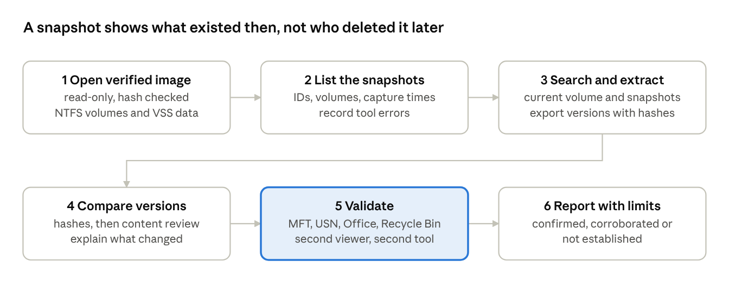
Figure 3 · shadow-copy recovery and validation workflow, 6 steps
- Open the verified image read-only and identify the NTFS partitions and any shadow-copy metadata.
- List the snapshots and record IDs, source volumes, capture times and tool errors.
- Search for the register and related browser records in the current volume and in each relevant snapshot.
- Export each useful version separately with its path, snapshot ID, metadata and SHA-256.
- Compare versions by hash and by reviewing the content; a different hash means the bytes differ, and the report should explain the actual changes.
- Cross-check against $MFT, USN journal, Office, Recycle Bin and approved cloud records to test whether editing, moving or deletion took place.
- Save the extraction log, open exports in a second viewer and state limits caused by missing or damaged snapshots.
Key limitation. A file present in the 18:00 snapshot but absent now shows that the two states differ. Without more evidence it does not show when it was deleted, by what process, or by whom.

Q28. Hypothetical file life-cycle timeline
The sequence below is invented, written in IST. In a real case I would also keep UTC and note clock uncertainty.
Time (hypothetical) | State of | Source | How it would be checked
05 Oct 09:30 | Created in Documents | NTFS $MFT | File record, path, vendor code
06 Oct 14:10 | Modified: payment totals revised | NTFS, Office recent files | Compare content versions
06 Oct 18:00 | Snapshot VSS-A taken; contains the revised file | VSS records | Snapshot ID, export hash
07 Oct 11:05 | Copied to a shared folder or e-mailed | Sync log, mail data | Provider action and object ID
08 Oct 22:12 | Deleted: rename or delete event, Recycle Bin emptied | USN journal, Recycle Bin | USN reason code, file reference
09 Oct 07:00 | Snapshot VSS-B taken; file already absent | VSS records | Snapshot ID
14 Oct 11:30 | Recovered from VSS-A during analysis | Forensic export | Read-only export, chain and hash
I would not read more into a USN entry than it shows. Office may create a temporary file and rename it during an ordinary save, and a file can be moved instead of deleted.

Q29. Validating the recovered artifact before reporting it
- ☐ Image hash verified against the manifest before and after extraction
- ☐ Snapshot ID, volume, capture time and tool build recorded
- ☐ Exact path, file record or offset, and metadata noted
- ☐ Export given its own exhibit ID and SHA-256
- ☐ File signature checked independently of the extension; file opens without silent repair
- ☐ Content compared with the current copy and any trusted business copy; similarity stated precisely
- ☐ Raw timestamps kept and normalized times shown; file creation time not confused with snapshot time
- ☐ Cross-checked with a second tool or second examiner
- ☐ Parser warnings, corruption and partial fragments disclosed

Q30. Sources of error and alternative explanations
- Snapshot timing: a snapshot only shows the state at capture; the edit may have happened earlier.
- Normal Office behaviour: temporary files, rename-on-save and cloud synchronization can look like deliberate deletion.
- Timestamp problems: wrong clocks, time-zone conversion, imported files or retained metadata can put events in the wrong order.
- Who used the account: a logged-in account may be shared, accessed remotely or used by a scheduled service.
- Missing copies: old snapshots can be deleted by clean-up or storage limits, and TRIM or overwriting can remove data.
- Uncertain recovery: a carved document may lose its name and folder and be mistaken for a similar one.
Case synthesis. If the shadow-copy records and the exported file validate, I could report that a given version of the register existed when that snapshot was taken. A later missing file with supporting NTFS records may suggest removal, but neither fact alone shows dishonest intent. Naming the person needs separate logon, process or other records.
Finding category | Reporting language
Confirmed (if validated) | "An earlier version of mess_vendor_payments.xlsx was recovered from snapshot VSS-A."
Corroborated (if supported) | "A file-system change event and a second source are consistent with later removal or replacement."
Not established | "The available material does not identify who removed the file."
The final evidence package would contain the classification table, snapshot register, original and recovered file details, version comparison, timeline, validation checklist and hashes, with only the finance information needed to explain the findings.

ASSIGNMENT 2(5) · Misused Library E-Journal Account Across Five Sources
Case scenario (hypothetical): On 12 October 2026, an online journal publisher complains to the college library that the student account stu_k417 downloaded several hundred articles in under an hour, which breaks the licence terms. The student says they did not do this. With written authorization, investigators can examine the student's Windows laptop, browser data, relevant e-mail and chat messages, an Android phone, and the library portal's cloud audit records. The main question is whether the student carried out the downloads or someone else used the account.
Assumptions: (1) The student has consented and the college has authorized the examination in writing. (2) Provider and portal records are requested through the proper channel. (3) Clocks and time zones are not yet verified. (4) The phone is unlocked by the student on request. (5) All entries below are invented examples.
Hypotheses. H1: the student ran the downloads. H2: someone else used stolen or shared credentials, or a hijacked session. H3: an authorized or automated tool (a reference manager or sync tool) caused the traffic.

Q31. Evidence from Windows and other operating systems
On the Windows laptop I would look for logon events and account profiles, browser data and downloads, recent files and jump lists, NTFS and USN records, scheduled tasks, installed tools (download managers, scripts, VPN or remote-access software), and system time settings. If a Linux or macOS device were involved, comparable evidence would be shell history, system logs, application histories and browser profiles. Each system needs its own validated collection method.
Being logged in to Windows, opening a browser profile and holding a valid portal session are three different observations. The report must say which layer each artifact identifies before drawing any conclusion about the student.

Q32. Browser artifacts and why they need careful interpretation
Browser history may show that the portal was visited, while cache, downloads, saved logins, form data, cookies and extensions give more context. Browsers can preload pages, sync history across devices, or reuse a stolen session cookie, so every browser clue is checked against the portal's own logs.
Browser artifact | What it may show | Main caveat
History with visit times | The portal pages were opened | Automated or preloaded visits are possible
Download list | Article PDFs were fetched to this machine | A download entry does not show who clicked
Cache and form remnants | Content or search terms used | May be stale or incomplete
Cookies and session tokens | An authenticated portal session existed | Holding a token does not identify the person
Extensions | A bulk-download or automation add-on | Could have been installed by someone else

Q33. E-mail and messaging evidence, and how to correlate it
Types of evidence: message content and attachments; headers (sender, recipient, message ID, delivery path, time); sent, received and deleted items; contacts; calendar entries; chat history and shared files; password-reset or "new sign-in" notices; and account login records.
Correlation with other artifacts:
- Match a password-reset e-mail with the provider's record of a reset.
- Match header times with browser activity and logon events.
- Compare an attachment with a file on the laptop by hash.
- Match chat messages about the account with the portal's access times.
- Compare sender and recipient addresses with accounts saved in the browser.
Sending, receiving and reading a message are different events, so I would not assume one proves another. Headers and provider records are stronger than a screenshot showing only a display name.

Q34. Mobile-phone forensic considerations and challenges
- Initial condition: photograph the screen, battery and connection state. Any decision to isolate the phone from the network follows a documented, device-specific plan.
- Permission and privacy: confirm whether the phone belongs to the student or the college, and collect only what consent or other lawful authority covers.
- Acquisition choice: logical, file-system or physical extraction depends on the model, lock state and what is lawful and possible.
- Useful material (if accessible): account identifiers, portal-app or browser activity, authentication prompts, notifications, downloads, location and Wi-Fi history.
- Challenges: device encryption and passcodes, many models and app versions, frequent updates, self-deleting messages, cloud-synced data, remote-wipe risk, and the risk of altering data during acquisition.
- Interpretation: a notification can be delayed or synced from elsewhere, and an approved login prompt does not prove the owner knew what was being approved.
- Handling: record the method, tool version, scope, device identifiers and integrity checks, and do not browse unrelated personal apps.
If the portal shows that a login approval succeeded at 20:41, I would ask which device received it and what was approved, and whether the laptop already held a valid session.

Q35. Internet and cloud evidence sources
The portal provider may hold login results, source IP addresses, user-agent strings, download counts, article IDs, times and session-revocation records. E-mail and cloud-storage providers hold sign-in history, device lists and sync records. Network records such as campus DHCP, proxy or VPN logs, and ISP address assignments add context. I would request them through the proper authority and check retention periods first.
Server records are valuable because they show what the portal accepted, not just what a device displayed. An IP address is still not a person: shared Wi-Fi, VPNs, NAT and mobile networks can make address-based attribution unreliable. Each export should state its scope, export time, time zone and the administrator responsible.
Evidence map: five sources, one question. The figure shows how the sources feed one timeline.
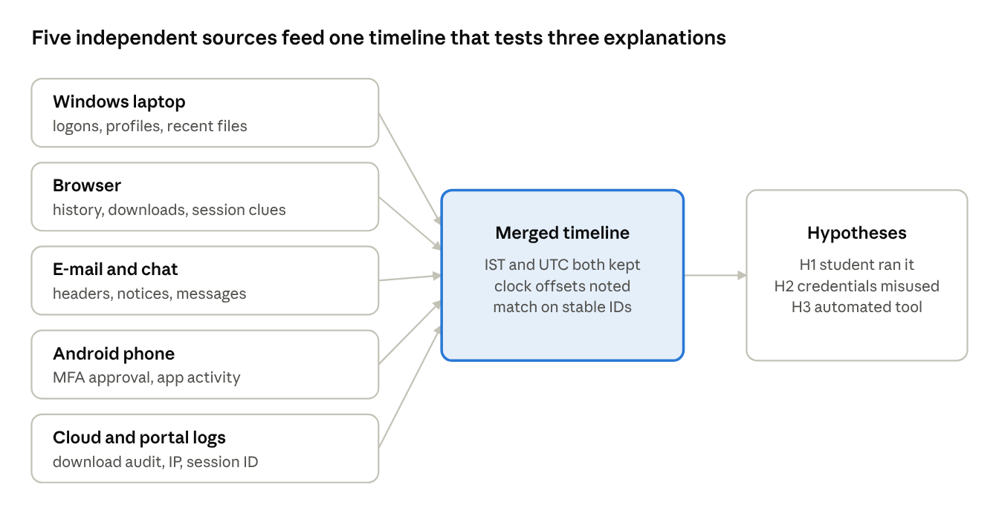
Figure 4 · multi-source evidence map, 5 sources, 3 hypotheses
Preserve first | Scope | Reason
Portal authentication and download audit | 11–13 Oct, this account | Rotating logs may be lost
Password-reset and sign-in notices | Same window | Tests whether the account was compromised
Authorized endpoint and browser state | Relevant profiles and dates | Shows device sessions
Provider-held article records | Download IDs and counts | Authoritative record of what was fetched
Network allocation records | IP-to-time mapping | Contextual source correlation
I would hash exported files, keep a record of how each was produced and include only the records needed for the incident.

Q36. Cross-source correlation table (hypothetical)
All times are IST and invented. Real analysis would also record UTC and any clock differences.

# | Source | Hypothetical artifact | Time | Correlates with | Limitation
1 | Windows computer | Account unlock on the student's laptop LAP-K417 | 12 Oct 20:32 | Browser session, portal log | The user at the keyboard is not identified
2 | Browser | Portal login page visited; download manager extension active | 20:38 | Portal log from the same IP | Visit does not prove who acted
3 | E-mail | Provider notice "new sign-in to your library account" | 20:40 | Portal audit and headers | Headers and provider records must be verified
4 | Mobile | Authenticator approval entry on the phone | 20:41 | Portal MFA event ID | What was approved is still ambiguous
5 | Cloud (portal) | Download burst of 300+ articles under stu_k417, session S-88 | 20:47–21:25 | Laptop session, IP assignment | IP and account do not name a person
6 | Messaging | Chat message from the student's number asking a friend about "bulk downloading" | 21:30 | Download burst, extension | The account or number could be impersonated
Correlation keys and alternatives. The strongest comparisons use stable values: a portal session ID, an article ID list, a device identifier or a verified account SID. Similar names, IP addresses and close timestamps are only supporting clues. I would test three explanations: the student did it (H1), another person used stolen credentials or a live session (H2), or an authorized tool caused the traffic (H3).

Q37. Challenges when evidence is spread across devices and cloud services
- Different permissions: cloud providers and personal devices need separate legal or administrative authorization.
- Short-lived evidence: provider logs, sessions, notifications and chats can be deleted or rotated.
- Encryption: modern phones and computers limit what a tool can obtain.
- Uncertain identity: an account name, IP address or MFA approval does not always identify the human.
- Different clocks: providers and devices use different time zones, delays and sometimes wrong clock settings.
- Changing formats: browser, messaging and cloud exports change, and not every tool can parse them.
- Too much unrelated data: investigators must avoid reviewing private messages and files unrelated to the incident.
- Chain of custody: screenshots and exports without a proper collection record are hard to verify later.
- Duplicate traces: one cloud event can sync to several devices, so a single action may seem to have several sources.

Q38. Final investigative conclusion
Tier | Possible conclusion in this scenario | What is still needed
Direct evidence | A validated portal audit would show that account stu_k417 fetched the articles in session S-88 | Original provider log, query provenance and export hashes
Corroborating evidence | Laptop unlock, browser extension, sign-in e-mail and the MFA approval may line up with the burst | Device and account ownership, authentic headers, normalized time
Unresolved questions | Who controlled the session, how the login was obtained, whether the approval was voluntary | Interviews, safe credential review, further lawful records
My provisional conclusion would stay within what the evidence supports. If the portal logs confirm the downloads, I could say that the student's account was used for them. I could not say the student personally ran them without further corroboration. The report should set out the alternatives (H2 and H3) and recommend proportionate steps: preserve logs, review the session and MFA settings, and talk to the student and the friend named in the chat.
When the laptop, browser, messages, phone and portal agree on the sequence, confidence in the timeline goes up. That agreement is still separate from the harder question of who acted and why.

References
Background references (they support the proposed workflows and do not replace approved laboratory procedures):
- NIST SP 800-86, Guide to Integrating Forensic Techniques into Incident Response.
- NISTIR 8387, Digital Evidence Preservation: Considerations for Evidence Handlers (2022).
- National Institute of Justice, test results for the IXimager digital data acquisition tool (historical report).
- Microsoft documentation on the Volume Shadow Copy Service (VSS).
- Information Technology Act, 2000, and the Bharatiya Sakshya Adhiniyam, 2023 (Section 63 on electronic records).
- CR23532 syllabus and the Case Study Assignments-II handout.

